Level 0:

Ethernet

USB Slots

PCI

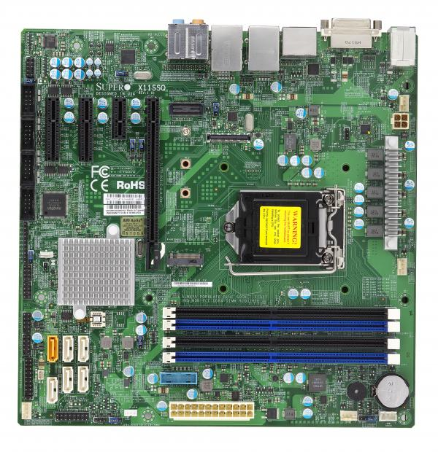

CPU Socket and CPU Fan

RAM SLOTS

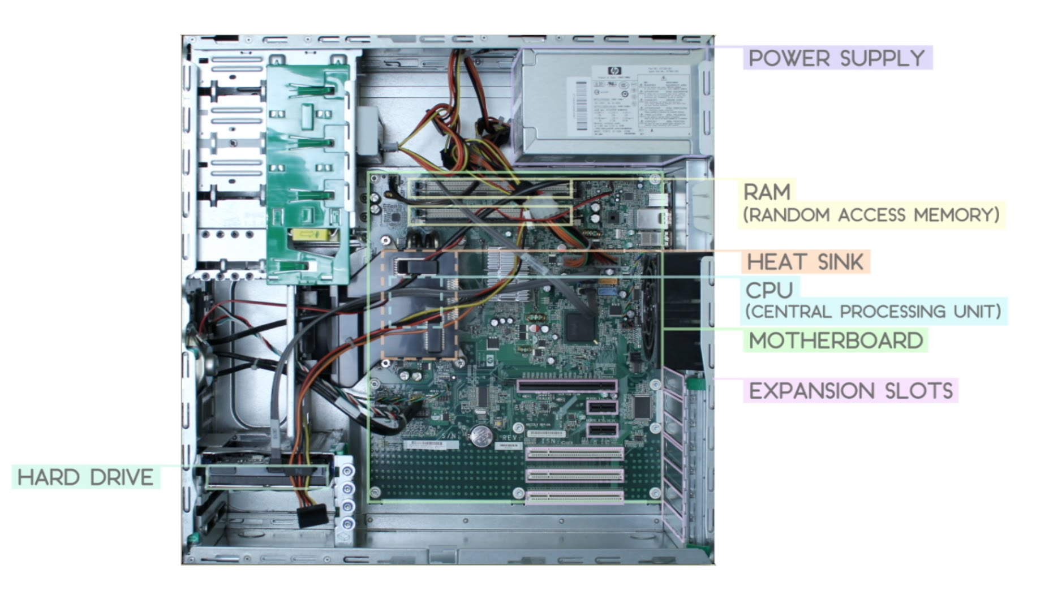

Power supply

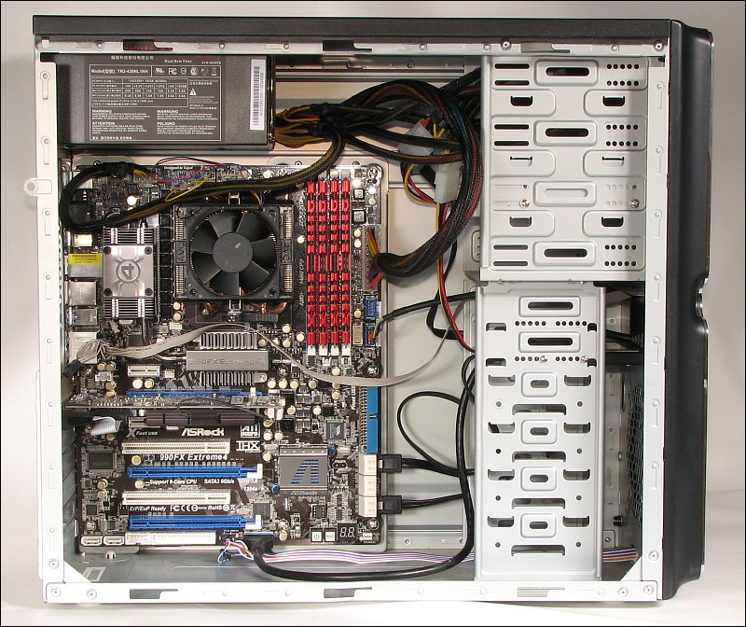

Connection to monitor,keyboard

Connected wire to hardrive

Hardrive

Level 1)

1a) This computer developed by J. Presper Eckert and John Mauchly, which used thousands of vacuum tubes.

b) In the 1960s IBM made the first automated mass production facility in New York

In the 1970s IBM introduced computers with Virtual Memory and memory chips

c) The mainframes in banks provide the necessary processing power to support banks, they support transactions, monitor for signs of fraud, perform analytics.

2a) The CRAY was released in 1976 and was made with 1,662 printed circuit boards with 144 IC’s in each.

b) The Deep Blue was made to play chess and handle complex calculations

c) Ram memory is temporary while external memory is permanent.

d)Ram was used for 0 or 1 binary back in the Late 1900s but now Ram can make calculations that no human can do on their own.

3a) VGA is a display hardware made in 1987, it has a 640x480 resolution characteristic

b) The D-subminiature

c) The first